1. Install nginx and run nginx on port number 81.

Installed nginx and checked status :

* Create instance and start a connection
* cd root
* yum install nginx
* systemctl start nginx
* systemctl status nginx
* netstat -na | grep 80
* lsof -i tcp:80
* ps -ef | grep nginx
* cat /etc/nginx/nginx.conf - to change port number
* cd /usr/share/nginx/html/ - default deployment location
* cat /var/log/nginx – error or access logs

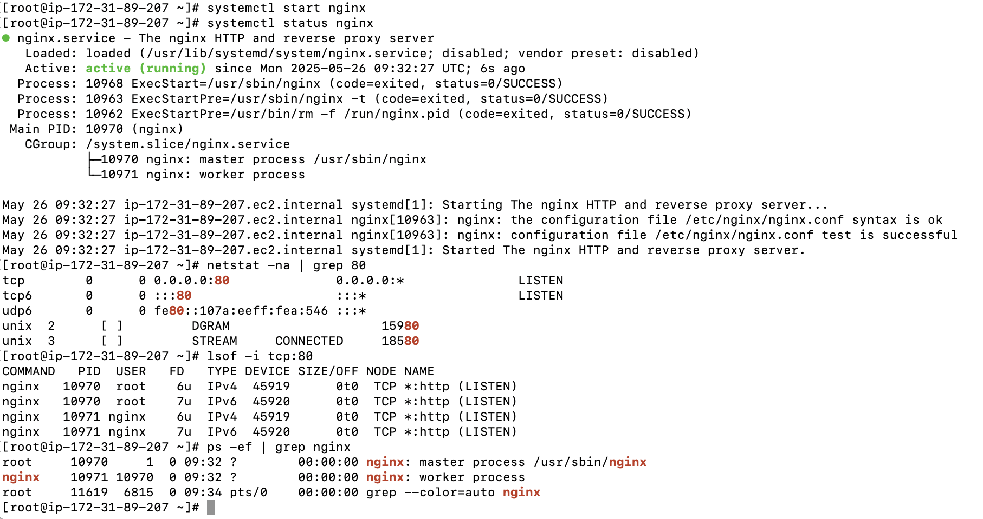

1. Deploy a sample index.html file on nginx.

1. Install Apache and run Apache on port number 82

* Create instance and start a connection
* Cd root
* Yum install httpd
* Systemctl start httpd
* Systemctl status httpd
* Netstat -na | grep 80
* Lsof -i tcp:80
* Ps -ef | grep httpd
* Cat /etc/httpd/conf/httpd.conf – change port number
* Cd /var/www/html/ - default deployment location
* Cat /var/log/httpd/ - error or access log

1. Deploy a sample index.html file on Apache.

1. Install Apache tomcat on port number 8082

* Install java openjdk
* Cd /opt
* sudo wget <https://downloads.apache.org/tomcat/tomcat-10/v10.1.41/bin/apache-tomcat-10.1.41.tar.gz>
* sudo tar -xvzf apache-tomcat-10.1.41.tar.gz
* sudo mv apache-tomcat-10.1.41 tomcat
* sudo nano /opt/tomcat/conf/server.xml – to change port number
* sudo nano /etc/systemd/system/tomcat.service – add service file
* browse content
* sudo systemctl daemon-reexec
* sudo systemctl daemon-reload
* sudo systemctl enable tomcat
* sudo systemctl start tomcat
* sudo systemctl status tomcat

1. Deploy a sample app on webapps

* change directory to webapps
* download sample.war file from google
* wget <url>
* systemctl restart tomcat

1. Create a tomcat.service file for tomcat.

Create the systemd service file

Use vi to add config in tomcat.service file



1. Configure HA Proxy server

Server 1 Steps:

Yum update -y

Yum install httpd -y

vi /etc/hosts

cat /etc/hosts

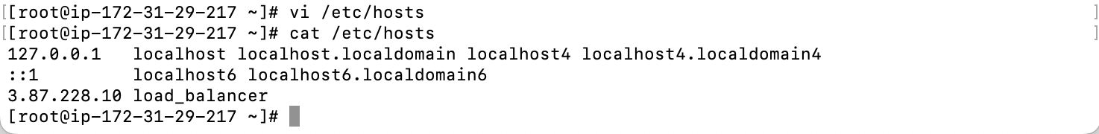

ping load_balancer -c 4

Systemctl start, status

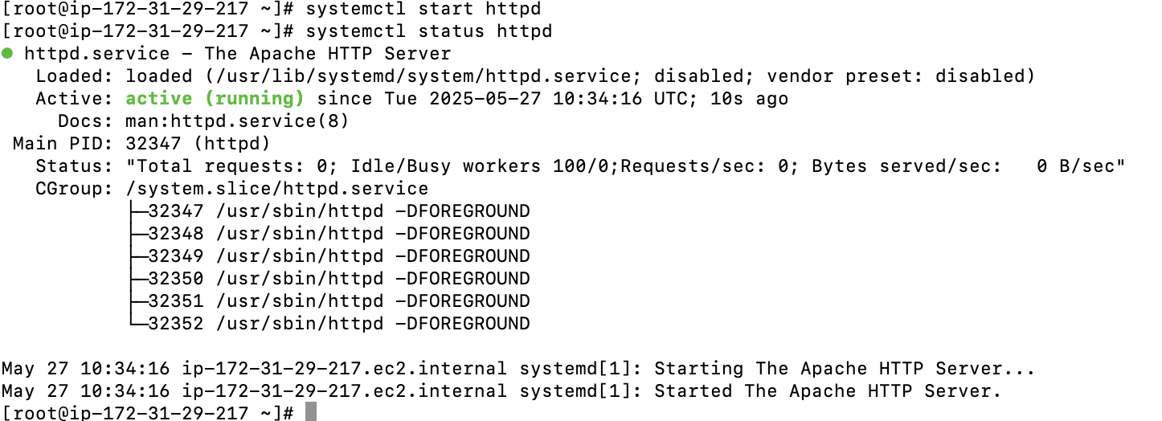

Server 2:

Sudo -I

Yum update -y

Yum install nginx -y

Sudo amazon-linux-extras install nginx1 -y

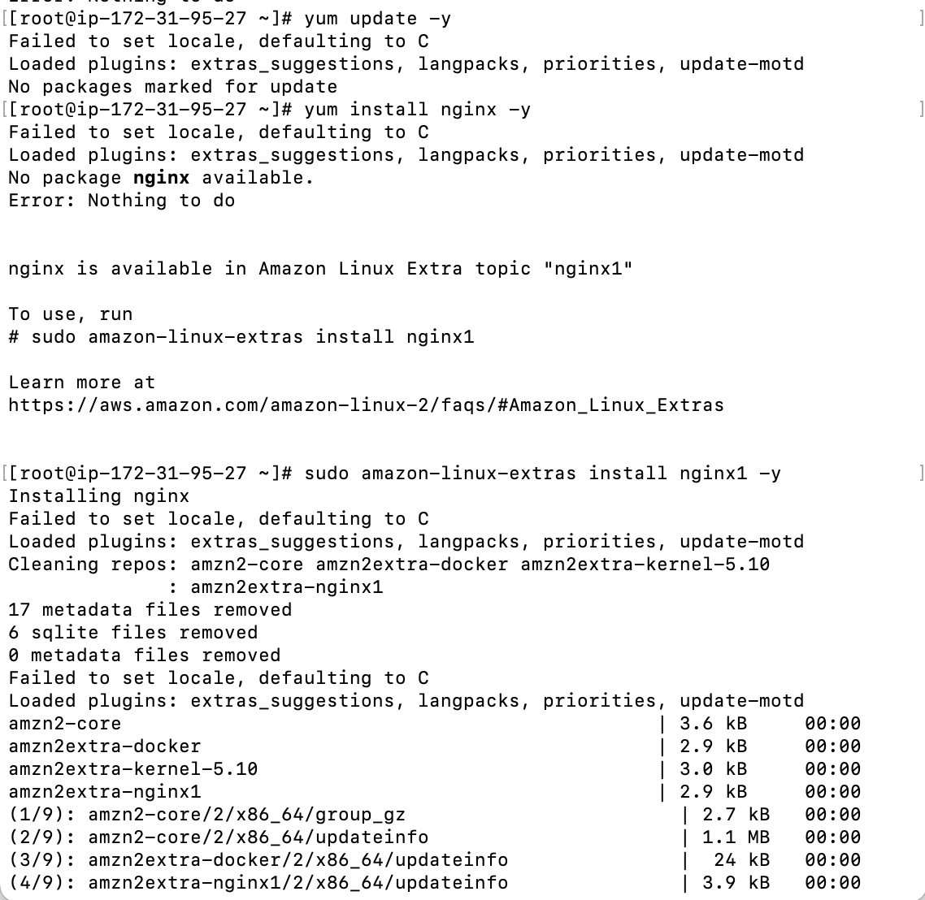

Vi /etc/hosts

Cat /etc/hosts

HA-Proxy Steps:





